Medieval Egyptian Sample Sock
By Eve the Just/Bree Flowers

Knitting this sock will teach you all the techniques you will need to make a full scale reproduction, except of course getting the perfect fit for your feet and calves. Reproduction socks should be knit in fingering weight cotton using natural and indigo dyed yarns. Sample socks may be knitted in any yarns of two contrasting colors. My sample was knitted in worsted weight on size 6 needles.

Medieval Egyptian socks of this type were knit from the toe up. A break in the pattern up the side of the socks suggests that they were knitted in the round.cf Inspection of images of extant objects leads me to believe they were using a star toe and an afterthought heel. Other examples were knit using short row heels. Bands of decoration were worked into the design using stranded color work and contrasting indigo-dyed cotton. Some socks were knit using only 2 colors (dark blue and white) while others were knit using 3 colors (dark blue, lighter blue and white). While most of the bands are primarily decorative, I believe that the band around the heel is done to make picking up stitches when replacing a heel easier. The afterthought heel is one of the most easily repaired heels because the entire heel can be removed and replaced without affecting the integrity of the rest of the sock. Having a band of a contrasting color would allow a knitter to easily and quickly pick up stitches, ensuring that they are picking them all up in the same row, to insert a replacement heel.

I do not have enough data to conclude with any sort of certainty what types of cast on and cast off were used in the extant examples. I have elected to use Judy’s Magic Cast On and a Russian Bind Off as these have worked well for me in the past. A knitter attempting this pattern should feel free to use their preferred methods.

Note that there is no ribbing or elastic to hold these socks up. They are meant to be worn with garters. If making a version of this sock for children or for wearing in the modern world, I would suggest adding a 1” cuff of 1x1 or 2x2 ribbing.

Text describing a fragment of knitting believed to be a sock in the Victoria and Albert collection states that “The gauge varies from ten stitches per twelve rows per inch at the toe to 7 stitches per ten rows per inch at the top, suggesting that shaping was achieved by changing the size of the needles as the knitting progressed.” We will not address leg shaping in this sample as it is not truly intended to fit any human feet, just to practice technique, but this is something to consider if the knitter wishes to recreate an adult sized sock that they intend to wear.

The Pattern
Please note that while the pattern is written for circular needles, medieval knitters would have been using double pointed needles. Feel free to use whatever style suits you best.

Toe
Using Main Color, cast on 8 stitches (4 per needle) using any preferred toe-up cast on. Directions for Judy’s Magic Cast On are in the appendix. Needle 1 will be the instep, needle 2 will be the sole.

Row 1: K1 *increase* repeat to end of needle 1, repeat for needle 2
Row 2: knit even
Row 3: K1 *K1 increase* repeat to end of needle 1, repeat for needle 2
Row 4: knit even
Row 5 K1 *K2 increase* repeat to end of needle 1, repeat for needle 2
Row 6: knit even
Row 7 K1 *K3 increase* repeat to end of needle 1, repeat for needle 2
Row 8: knit even
You should now have 32 stitches (16 per needle)

Note: general instructions for a star toe: If you do not wish to count rows, place markers after each increase on the first round, and perform subsequent increases on the last stitch before the marker until you have reached your desired number of stitches.

Foot
Work stranded pattern over next 13 rows (see colorwork chart in appendix)
Knit 5 rows even in main color

Setting up the Heel
Knit across needle 1 in main color
Using a scrap piece of yarn of the same gauge as your piece, knit across needle 2 using a DPN of the same size as your circulars (or a second circular)
Knit across needle 2 in main color (yes, you are knitting across the same needle twice, starting from the right, just like normal. Do not turn the work or go backwards.)

Leg
Knit 5 rows even in main color
Work stranded pattern over next 13 rows (see colorwork chart in appendix)
Knit 5 rows even in main color
Bind off using preferred method, ensuring lots of stretch. Directions for Russian Bind Off are given in the appendix.

Heel
Starting from the right side of the last row of main color before the scrap yarn (the side of the scrap stripe nearest the toe) pick up 16 stitches. You may wish to pick up an additional stitch at the beginning and end for less of a gap at the apex of the heel. Using a second needle, or if doing magic loop, pull your needle through and continue with the same point, pick up the same number of stitches on the other side of the scrap yarn stripe. If using double pointed needles, you may wish to go down a size or two when picking up these stitches to give yourself more space to work, but continue knitting in the same size as the rest of the piece. If using circular needles, place all stitches on cables to give yourself room to work. Carefully pick out the scrap yarn, revealing live stitches.

Row 1: Using contrast color, knit even If you picked up extra stitches when starting the heel, reduce down to 32 stitches (16 stitches per needle) on this row.
Row 2: Using main color, knit even
Row 3: K1 SSK Knit to 3 stitches before the end of needle 1 K2TOG K1, repeat on needle 2
Row 4: Knit even
Repeat row 3 and 4 two more times until you have 20 stitches (10 per needle)
Repeat row 3 two more times until you have 12 stitches (6 per needle)
Graft these stitches together using kitchener stitch.
Note: General instructions for Afterthought heel. Perform approximately half (or a little more) of your decreases with a knit even row between them, then perform the rest of your decreases without knit even rows. The number of stitches remaining when you perform your kitchener graft should be approximately 1/3 of the number of stitches picked up when you started the heel. Do not substitute a bind off, only the graft will result in a smooth, comfortable heel.

Appendix:
Abbreviations Used:
Increase: can be either “M1, K1” or “Knit Front and Back”
SSK: slip, slip, knit – slip 2 stitches as if to purl, knit these 2 stitches together through the back loop
K2TOG: Knit 2 together

Judy’s Magic Cast On
Hold your needles together in your right hand with points facing towards the left.
Lay your yarn over the top needle, with the tail falling on the far side.

Step 1: Using your left hand, pick up the tail with your index finger and the yarn that goes to the ball with your thumb. You may use a slip knot instead of laying the yarn over the needle for more security, but then there will be a knot in your finished sock.

Step 2: Wrap the tail yarn under both needles, then around the bottom needle and down between the needles, wrapping it around the bottom needle.
Step 3: Wrap the yarn on your thumb under both needles then around the top needle and down between the needles, wrapping it around the bottom needle.
Repeat step 2 and 3 (ending after step 2) until you have the correct number of loops on each needle. Note that the yarn laid over (or slip knotted on) the top needle in step 1 counts as a loop.

Step 4: Turn your needles so that the points face to your right. You will begin knitting on what is now the top needle.

Step 5: “Lock” your tail in place by ensuring it passes over your active yarn (between the active yarn and the needle)

Step 6: Knit across needle 1

Step 7: Knit across needle 2 through the back loops as these stitches are twisted.

Russian Bind Off
Step 1: K2 and slip these two stitches as if to purl back to the left needle.
Step 2: K2TOG through back loops
Step 3: K1 slip 2 stitches as if to purl back on to the left needle (leaving right needle empty)
Step 4: K2TOG through back loops
Repeat steps 3 and 4 until all stitches are worked.

Chart for colorwork
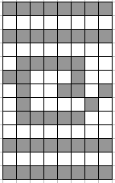

Redrawn from Richard Rutt’s A History of Hand Knitting. Please see this book for more charts that could be used on adult socks.

Bibliography, Images and Additional Resources:

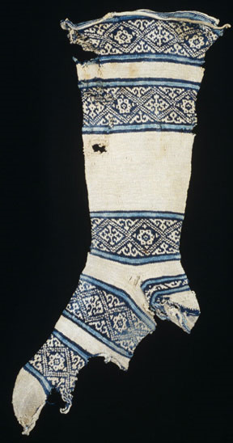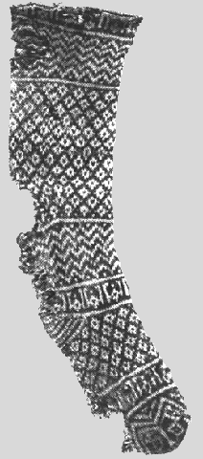
Textile Museum, Washington DC, 11th-13th Century
Note that the sock on the left uses an afterthought heel while the sock on the right uses a short row heel.
http://www.textilemuseum.org/totm/islamicsockindex.htm

Victoria and Albert museum
http://collections.vam.ac.uk/item/O128882/sock/

Dar Anahita's Medieval Muslim Knitting
http://home.earthlink.net/~urtatim/
Richard Rutt, A History of Hand Knitting, 1987.


